

SIMATS ENGINEERING

Saveetha Institute of Medical and Technical Sciences
Chennai- 602105

Student Name: Juhi Surin Reg. No.: 192525148
Course Code: MLA0101 Slot: A
Course Name: Artificial Intelligence with Expert Systems
Course Faculty: Dr. Subramanian P
Project Title: AI-Enhanced Voice Recognition System for Arduino LED Control
Module Photographs:
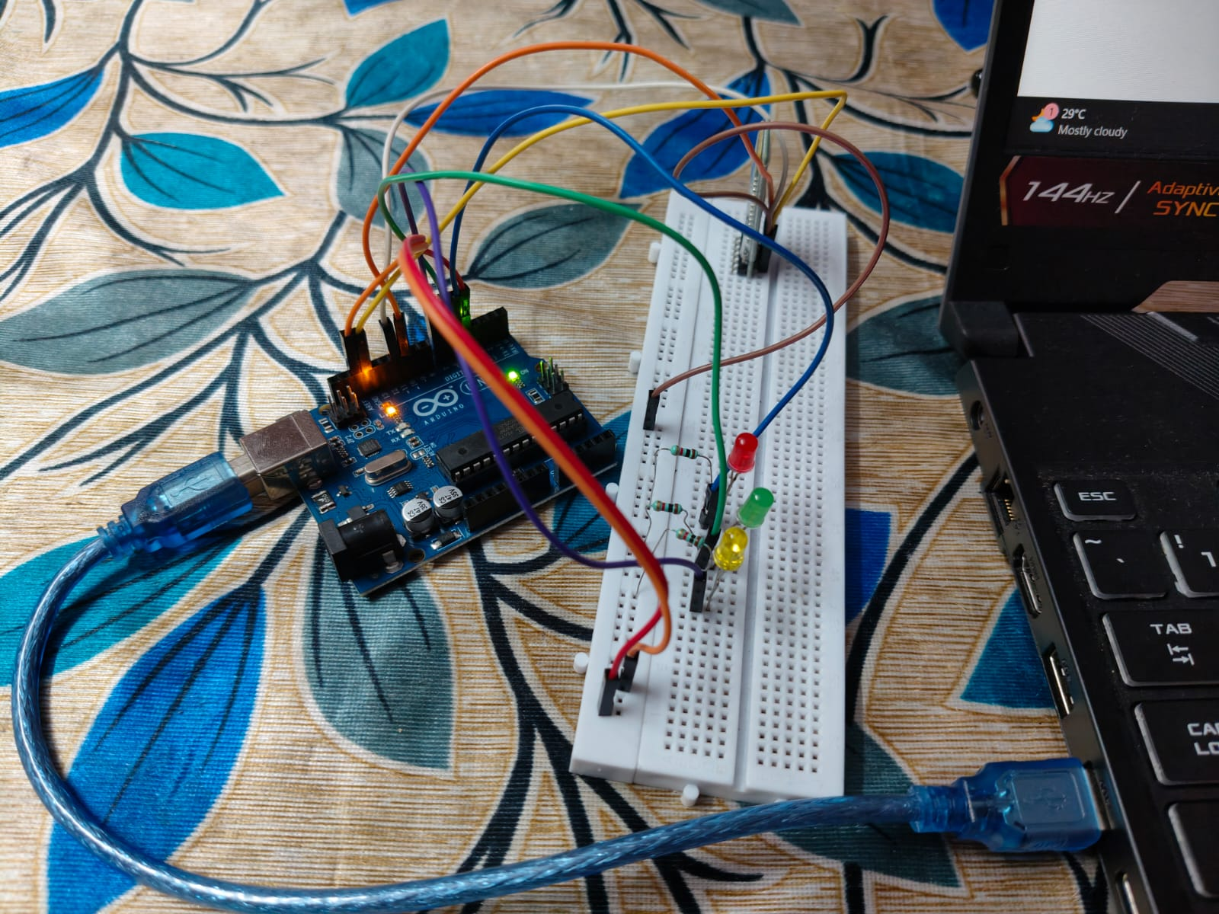

Project Description: Module 3: ARDUINO LED CONTROL
The AI-Enhanced Voice Recognition System for Arduino LED Control is a smart automation project that combines Artificial Intelligence, voice recognition, Bluetooth communication, and Arduino Uno. In this system, the user gives a voice command through a microphone or smartphone, and the AI-based voice recognition system identifies the intended command. The recognized command is then transmitted wirelessly to the Arduino Uno using the HC-05 Bluetooth module. Based on the received command, the Arduino processes the instruction and controls the Red, Green, or Blue LED accordingly. The system provides a simple, affordable, fast, and hands-free method of controlling electronic devices through voice commands, making it suitable for smart-home automation and similar applications.
Module 3 is responsible for executing the commands received from the Bluetooth module and controlling the LEDs connected to the Arduino Uno. The Arduino receives the recognized voice command through the HC-05 Bluetooth module and compares it with a set of predefined actions. When a matching command is identified, the Arduino activates or deactivates the corresponding GPIO pin. This causes the required Red, Green, or Blue LED to turn ON or OFF according to the user's voice instruction. For example, when the command “LED_ON” is received, the Arduino sets the corresponding GPIO pin to HIGH, which switches the LED ON. Thus, this module acts as the final control stage that converts the AI-recognized voice command into a physical LED action.

Student Signature Guide Signature

